Millbrae Hander Medical Center Expansion: Case Study
The Millbrae Hander Medical Center has been an inner-city outpatient medical facility for 12 years and is in need of expansion to include more examination rooms as well as the addition of inpatient rooms. Millbrae Hander, founder of the medical center, passed away 5 years after the facility was opened, and the Millbrae Hander Foundation has succeeded in managing the operations of the medical center in his absence. This medical center has become a landmark facility within the community because it not only caters to the inner-city community but also has served as an educational platform for medical interns. The medical center, currently sized at 36,000 square feet, is suffering from overcrowding in the limitation of outpatient service only and lack of examination rooms and staff preparation areas. The medical center has undergone two small remodeling endeavors to remedy this situation, but the increased demand for medical services continues to put pressure on the size of this much-needed medical facility.
City planning has authorized an expansion of 10,000 square feet to the existing facility and use of property and parking adjacent to the existing facility that the medical center currently owns. The medical center has a combination of two large donations and has secured low-interest financing to manage the remainder of the total financial responsibility. The director and staff of the medical facility are excited about the approval of this expansion and want to move forward with project planning.
An architectural firm has been identified to produce all building specifications, drawings, and documentation necessary for city permits to be drawn. A project management firm has been identified to manage the construction and move in phases for this project. Representatives from the Millbrae Hander Foundation, the executive director of the medical center, and key department staff supervisors have formed a panel of stakeholders to identify what is needed in the expansion of the medical center. A list of critical areas and a general project budget have been formulated and communicated to the architectural firm, and an overall project duration of ten months has been established for completion of the expansion project. At this point, the project manager only has financial information for the building and land at $525,000 and an initial budget of $725,000 for medical equipment and supplies. The stakeholder panel has issued an initial project budget of $1,300,000 and has communicated that only $25,000 emergency buffers are available. The stakeholder panel has also issued the requirements as to what will be included in the expansion, as listed here:

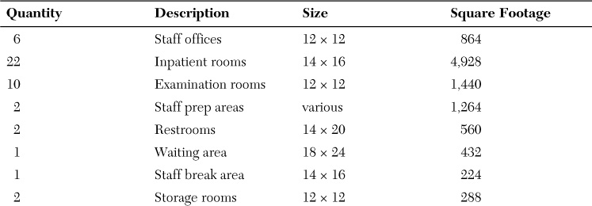
Based on your previous readings and this week’s assigned readings, apply the concepts and principles to address the items below in respect to the case study (see the rubric below):
- How would the project manager use a project management plan in this process?

As the project manager, I'll utilize a project management plan to organize the expansion project, including defining the scope, schedule, budget, roles/responsibilities, and creating a risk management and communication plan.

- Choose a budget development method and explain your selection.

The budget will be developed using the bottom-up approach, estimating costs of individual tasks/activities and aggregating them for the overall project budget, providing more detail and accuracy.

- Establish a project budget baseline.
The budget baseline is $1,300,000 set by stakeholders, with additional costs for architect fees, permits, furniture, etc.
- Is budget contingency planning necessary?

Budget contingency planning is crucial due to a limited emergency buffer of $25,000, identifying potential risks to ensure project completion with unexpected costs.

- Identify other necessary items that do not have assigned costs, such as architect fees, permits, parking lot, landscaping and signage, furniture, and so on.

Uncosted items such as architect fees, permits, parking, landscaping, signage, and furniture must be included in the budget.

- What is meant by cost aggregation? Why is it applicable or not to this case?

Cost aggregation involves combining costs from different levels of the project to form the overall budget.

- What is meant by managing the triple constraint? Why is it applicable or not to this case?

Balancing the demands of scope, schedule, and budget (managing the triple constraint) is essential to meet stakeholder panel constraints.

- Are there any cost constraints? If so, what might it be?

Cost constraints are $1,300,000 and $25,000 emergency buffer.

- What cost estimating technique would you use in developing the cost estimates for this project and why?

Analogous estimating will be used for cost estimating, relying on similar project costs for a rough estimate.

- Explain the pros and cons of outsource contracting.

Outsourcing contracting has cost savings and access to specialized skills/expertise, but lack of control and communication issues must be weighed before a decision is made.

